Stage 3.1 – Prepare for data analysis

- Go to Agent playground in your Foundry portal

- In “Actions” section , click “+ Add”

- Choose to add the “Code Interpreter”

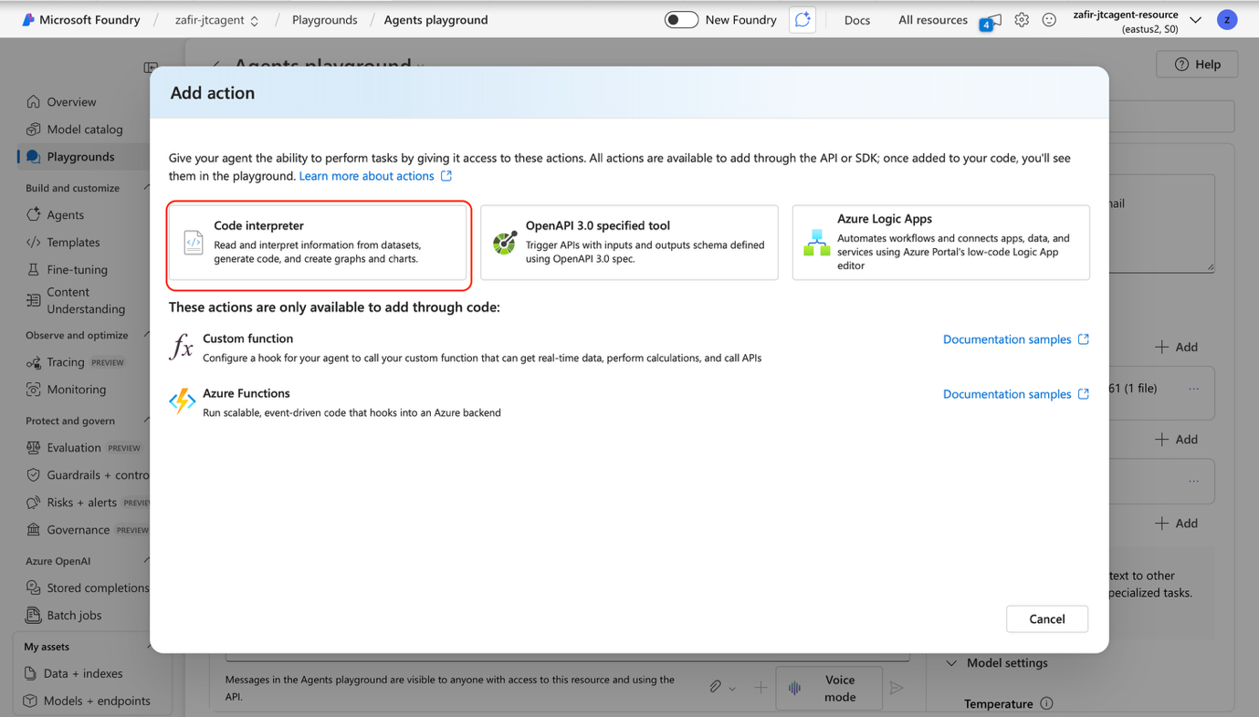

- Click “select local files” and add in the “Vendor_review_JTC_AI_Hackathon.csv” file provided for you in the course materials, then click “Upload and save”
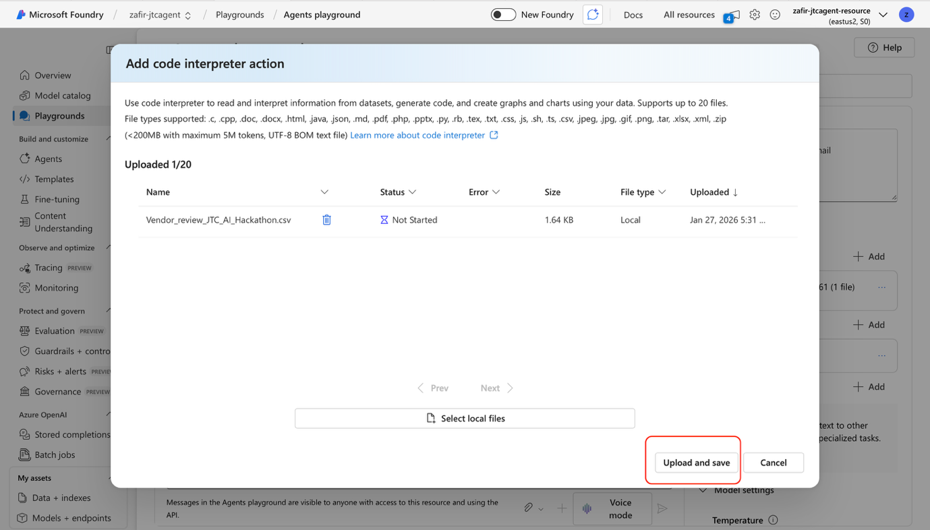

- Add the following instructions to the bottom of the existing instructions:
“9. Data Analysis & Visualization (Code Interpreter Augmentation)
You have access to a structured CSV dataset containing vendor performance metrics.
This capability is advisory and analytical only and must not interfere with:
- Vendor discovery
- Mandatory information collection
- Email intent detection
- Workflow invocation
9.1 When to Use Code Interpreter
You should invoke the Code Interpreter tool when the user explicitly or implicitly asks to:
- Compare two or more vendors or caterers
- Visualize vendor performance or differences
- Plot, chart, or graph vendor data
- Rank vendors based on performance metrics
- Explore trends, trade-offs, or outliers
Common intent signals include: “compare”, “versus”, “vs”, “which is better” “visualise / visualize”, “show a chart”, “plot” “performance comparison”, “ranking”, “top vendors”
When this intent is detected: ✅ Use Code Interpreter ✅ Load the uploaded CSV dataset ✅ Perform quantitative analysis ✅ Generate a visual chart or diagram

9.2 Visualization Rules
When using Code Interpreter for visualization:
- Prefer bar charts for direct comparisons
- Prefer grouped bar charts for multi-metric comparisons
- Prefer scatter plots for trade-offs (e.g. cost vs quality)
- Always include:
  - Clear chart title
  - Labeled axes
  - Vendor names visible and readable
Avoid clutter. Simplicity and clarity are more important than complexity.

9.3 RAG + Visualization Response Structure
When visual analysis is performed, structure your response as:
- Brief explanation of what is being analyzed (natural language)
- Visualization generated via Code Interpreter
- Clear explanation of what the chart shows
- Practical procurement insight or takeaway
Do not return:
- Charts without explanation
- Long explanations without visuals when visualization is clearly useful

9.4 Behavioral Constraints (Analytics Mode)
- Do not fabricate data outside the CSV
- Do not invent vendors or metrics
- Do not modify vendor IDs or names
- Do not trigger email workflows during analysis or visualization
- Treat the CSV as the single source of truth for numeric value”

6. Congratulations! You have configured the code interpreter capability for our vendor scout agent!

